Article

Optimization of land-based impact zones for spent rocket stages launched from the Baikonur Cosmodrome

Gulnaz Yermoldina1,2*, Aliya Yskak1, Nurlan Suimenbayev3, Elmira Yermoldina4

|  |
| --- |
| Academic Editor: Firstname Lastname  Received: date  Revised: date  Accepted: date  Published: date  **Citation:** To be added by editorial staff during production.  **Copyright:** © 2025 by the authors. Submitted for possible open access publication under the terms and conditions of the Creative Commons Attribution (CC BY) license (https://creativecommons.org/licenses/by/4.0/). |

1 Non-profit limited company «Akhmet Baitursynuly Kostanay Regional University», yermoldina.g@ksu.edu.kz

2 Kazakh national university named after Al-Farabi, Almaty, Kazakhstan, [gulnazyermoldina@gmail.com](mailto:gulnazyermoldina@gmail.com)

3 National Centre of Space Research and Technology, Almaty, Kazakhstan, [n.suimenbayev@gmail.com](mailto:n.suimenbayev@gmail.com)

4 Branch Office of the Republican State Enterprise "Infracos", Almaty, Kazakhstan, Eermoldina@gmail.com

**\*** Correspondence: e-mail@e-mail.com; Tel.: (optional; include country code; if there are multiple corresponding authors, add author initials)

|  |
| --- |
| Академический редактор: Имя Фамилия  Получено: дата  Исправлено: дата  Принято: дата  Опубликовано: дата публикации  **Цитата:** Добавляется редакцией во время производства.  **Авторские права:** © 2025 авторы. Представлено для возможной публикации в открытом доступе на условиях лицензии Creative Commons Attribution (CC BY) (https://creativecommons.org/licenses/by/4.0/). |

**Abstract**

The article presents a comprehensive methodology for optimizing ground impact zones of spent rocket stages based on the integration of geoinformation analysis, remote sensing of the Earth, ballistic modeling, and ecosystem sustainability assessment. An information and analytical system (IAS) has been developed and tested, providing automated selection of environmentally sustainable landing points within acceptable dispersion zones. The methodology includes the use of the NDVI index, digital terrain models, soil quality assessments, fire hazard assessments, and environmental damage calculations. For the first time, a system for classifying operational-territorial units according to their level of resistance to man-made impacts has been formed. The results obtained demonstrate the possibility of reducing the potentially dangerous impact zone by 5-10 times while maintaining high forecasting accuracy and environmental safety. The developed system is highly scalable and applicable to other spaceports located in continental regions. The presented methodology contributes to the development of an environmentally oriented approach to aerospace infrastructure management.

**Keywords:** controlled descent, environmental safety, launch vehicles, impact areas, information and analytical system, operational-territorial unit

**1.Introduction**

Space rockets affect virtually all of Earth's geospheres and its surface up to geostationary orbits. The impact on the environment is very diverse: acoustic, thermal, mechanical, chemical, and radioactive. In some cases, these types of impacts are interrelated, and their contribution to the overall disturbance depends on the type of launch vehicle, flight altitude, equipment operation, emergency situations, and the technology used in the rocket and space complex.

Spacecraft launches are always accompanied by the fall of detachable parts of launch vehicles (LVs) to the ground. These include spent stages, payload fairings, and connecting compartments that ensure the launch of the rocket. The size and location of the fall areas for these parts for each route are determined by the requirements for spacecraft orbits, their mass, and the energy characteristics of the rockets, and are selected, where possible, in areas with the lowest population density and minimal economic activity.

In Russia and Kazakhstan, the location of spaceports is such that significant areas of the fall zones of spent launch vehicle stages are located on their own land territory. Unlike Russia and Kazakhstan, where spent rocket stages often fall on land, the main fall zones for countries such as the United States, the European Union, Japan, India, and Brazil are often located over oceanic areas. However, this does not eliminate environmental safety issues entirely, but rather shifts them toward marine ecosystems. Thus, oceanic and continental landfalls present different environmental challenges. The development of reusable and controlled descent systems, such as those used by SpaceX, offers an effective way to mitigate both types of impacts.

The problem of contamination of large areas where the first stages of launch vehicles fall with unused residues of toxic rocket fuel components (RFC) has always been and remains a pressing issue for Kazakhstan [1-2]. The solution to this problem has so far mainly consisted of decontaminating the sites of spills of highly toxic rocket fuel components.

The problem of optimizing and reducing the landing areas of first stages of rockets becomes particularly relevant in the case of their deployment on land, especially when it comes to newly developed areas. For example, to ensure the launch of the Soyuz-2 rocket from the Baikonur cosmodrome along a new route in a northerly direction to near-polar orbits, a new area of about 6,000 hectares has been opened in the Kostanay region of the Republic of Kazakhstan for the fall of separable parts of the launch vehicle [3].

Many researchers highlight the most important factors that negatively affect the environment during the operation of rocket and space technology: emissions of gases [4], ozone-depleting substances [4-5], mechanical pollution with fragments of stages and rocket fuel residues, and pollution of natural terrestrial ecosystems (soil, water, air, plants) with toxic rocket fuel components [6].

Rocket fuel decomposition products have been found in vegetation, soil, and bottom sediments, as well as in groundwater and surface water, in concentrations significantly exceeding permissible limits [6]. The impact of toxic combustion products on the human body is also extremely dangerous.

The high toxicity of the rocket fuel components used, their stability, ability to accumulate and migrate, and the ability of their decomposition products to transform into more toxic substances and enter the human body through food chains all pose a threat to human health and the environment [7].

Thus, in [1], changes in vegetation were studied over two growing seasons in the area where the first stage of the Proton-M rocket fell, and suppression of vegetation cover, poor species diversity, and a long period of succession were demonstrated.

Rocket fuel components are stable in soil, accumulate, and persist for a long time. At the same time, high concentrations of various toxicants have a detrimental effect on the vital activity of soil organisms [8]. Soil microbial communities are the most vulnerable component of arid ecosystems, which include the studied areas affected by the first stages.

The suppressed state of the soil microbiota is evidenced by low biochemical oxygen demand and very low cellulase activity [8]. Accordingly, the soil loses its ability to self-clean from pathogenic microorganisms and other undesirable microorganisms, which has serious consequences for humans, flora, and fauna. As many researchers note, incoming toxicants accumulate, gradually changing the chemical and physical properties of the soil, reducing the number of living organisms, and worsening its fertility [9-10].

In the event of emergency and abnormal launches of carrier rockets, the serious consequences of negative impacts on ecosystems increase many times over [8,11]. Article [10] presents the results of many years of research on emergency launches. The dynamics of the consequences of accidents indicate an increase in the area of ecological anomalies, destruction of soil and vegetation cover, vegetation fires, and significant soil contamination [7].

Mechanical damage to the soil at the crash sites of the first stage of the Proton launch vehicle manifests itself in the formation of craters of various diameters and the destruction of soil and vegetation cover. According to [9], large fragments are scattered over an area of more than 1,200 m2, and small fragments over an area of more than 22,000 m2. The area of vegetation fire reaches more than 245,588 m2, and the spill of fuel components (nitrogen tetroxide and unsymmetrical dimethylhydrazine) reaches up to 737 m2 [9]. The debris from the Soyuz spacecraft's side blocks covers an area of 325 to 43,627 m², the vegetation fire covers an area of more than 8,000 m², and the fuel spill covers an area of up to 129 m² [8].

Works [12-13] propose measures to reduce the environmental impact, including various detoxification methods [12] and the rapid search for fallen rocket stage fragments [13].

Mechanical contamination with fragments of first-stage rocket boosters and chemical contamination with fuel components occurs in specially designated areas – the landing sites of spent rocket stages [1-2,4-13].

Residues of fuel and other chemicals used in rockets can create toxic contamination sites that pose a threat to ecosystems and the health of people living in the immediate vicinity of the spaceport. For example, between 1957 and 2022, more than 2,200 launches were carried out from the Baikonur Cosmodrome.

An analysis of the comprehensive assessment of the impact of rocket and space technology launches on the environmental condition of the affected areas and adjacent territories of Baikonur allows us to draw the following main conclusions:

- the impact of rocket and space activities can be traced at all levels of the environment;

- the fall of an emergency rocket from a complex launch (RKN) to the ground leads to an explosion as a result of fuel detonation, and in this case, factors arise that affect the safety system in the form of fuel component spillage, shock waves, thermal radiation from the fireball, and flying fragments of the RKN structure. Moreover, this impact occurs uncontrollably.

The contamination of the launch sites of carrier rockets with toxic rocket fuel components is the most acute environmental problem in the history of the Baikonur complex. Thus, when launching the Proton Proton launch vehicle, the planned release of unused fuel residues from the first and second stages into the atmosphere amounts to ~2.6 tons, and in the event of an accident on the launch vehicle, tens of tons of highly toxic fuel enter natural ecosystems (atmosphere, soil, water, plants, etc.).

In accordance with the lease agreement for the Baikonur complex [14] in Kazakhstan, 51 fall zones with a total area of more than 4.14 million hectares have been designated for rocket launch sites (see Fig. 1). The terms of the agreements provide for measures to ensure human safety, environmental monitoring, and environmental protection during each launch in the landing areas.

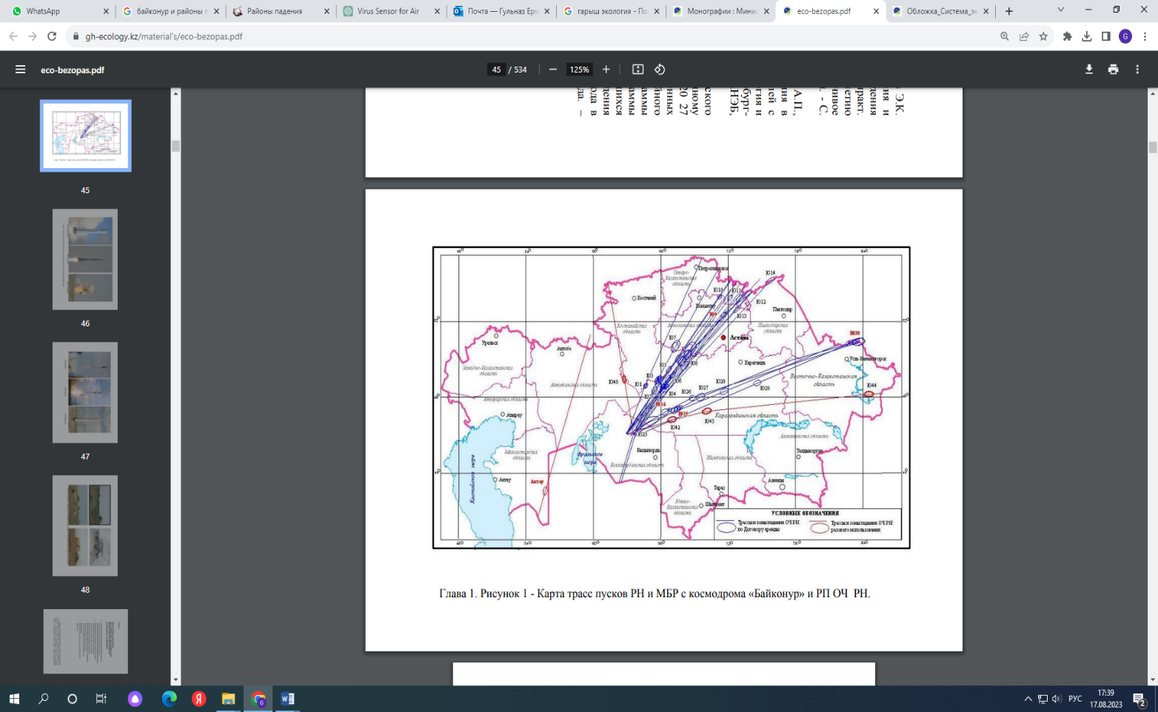

**Figure 1.** Map of launch vehicle's launch route from the Baikonur Cosmodrome and impact areas of separating launch vehicle parts

Rocket launches affect the environment, first of all, in the area where the launch vehicle is located, where the LV crashes and in the crash sites along the launch route (Figure 1). Launches have both a specific impact on the environment (typical for this kind of object) and a non-specific one (similar to the industrial general effects) [15-16].

The results of expeditionary studies of the impact areas of the Soyuz and Proton launch vehicles indicate air pollution and water, and the accumulation of pollutants in the soils affected areas (Figure 2). Studies by many authors confirm the detection of rocket fuel in environmental objects and biota, and indicate a decrease in the content of stratospheric ozone, significant changes in soil properties, and a decrease in the diversity of plant species [1-2, 4-13, 15-21].

|  |  |
| --- | --- |
|  | Связанное изображение |
| (**а**) | (**б**) |

**Figure 2.** Consequences of the landing of the spent stage of the Soyuz-2 LV (August 2023)

In general, the analysis of the results of research on the current state of the impact areas of the LV’ stages gives an idea of the environmental consequences of rocket activities for the soil and vegetation of Central Kazakhstan and indicates the need to find new solutions to ensure the ecological safety of the ground infrastructure of the spaceport.

The paper [22] proposes the following approaches to the environmental support of safe missile launches:

1. Improving the means and methods of searching for and detecting rocket stage fragments.

2. Developing the infrastructure of the fall area (creating support points for storing found fragments for preliminary burial and removal outside the IA).

3. Development of technical means for searching for and detecting rocket stage fragments.

4. Comprehensive environmental monitoring of the impact zone in close contact with interested organizations.

5. Organization of special “commercial” routes for safe observation of the flight of the launch vehicle stage and the fall of stage fragments.

Other researchers propose various solutions for compliance with safety requirements [23], the creation of advanced engine and control systems technologies [24], the use of less toxic fuels, the development of fuel tanks, the optimization of stage design and flight trajectories [25], and the development and optimization of reusable launch vehicles [26-29].

Currently, there is a growing demand worldwide for the development of reusable launch vehicles [30-31].

Controlled descent of the used rocket stage is one of the proven methods of reducing the technogenic load [32-33]. An example of such a comprehensive solution to an environmental problem is the SpaceX project, in which the first stage of the launch vehicle, after performing a maneuver in the atmosphere, lands on a platform used as a landing site for controlled descent. Several innovative projects are being developed based on a similar model [18, 34-38].

The technology of controlled descent of the spent rocket stage reduces the environmental impact on ecosystems, reduces harm to the environment, and lowers the cost of its restoration.

At the same time, it is important to understand the challenges and solutions associated with ensuring the environmental safety of Baikonur facilities during the regulated descent of the spent rocket stage.

In works [24, 33-35, 39], a new approach to radically reducing impact zones is proposed. This approach involves the additional installation of an onboard descent system on the stages of the launch vehicle, ensuring that it falls at a specified point in the impact area. According to this concept, the impact area is reduced. This allows for the optimization of these territories, taking into account environmental safety requirements [36-44].

Currently, environmental requirements are mainly limited to recommendations not to use toxic fuel components [8, 17, 22].

The task of optimizing the landing areas for rocket stages and assessing the corresponding environmental damage is particularly relevant for land areas where spent rocket stages fall [41].

Therefore, the development of an effective system for predicting the exact landing zones of rocket stages and assessing the environmental situation in these zones is a pressing task.

Solving the optimization problem involves the design and operation of an additional information system as part of the existing monitoring system at Baikonur [36, 44]. This information system (Information and Analytical System – IAS) should provide an assessment of the success of design solutions for the safe operation of the launch vehicle and an objective analysis of the consequences of LV launches.

The operation of the IAS will reduce the environmental impact on the IA ecosystems, form operational reserves of landing points for spent stages at the IA site, and monitor these points.

The scientific novelty of this study lies in the development and testing of a comprehensive methodology for predicting the landing sites of spent rocket stages, based on the integration of geoinformation analysis, remote sensing, ballistic modeling, and assessment of the ecological sustainability of ecosystems. For the first time, an information and analytical system (IAS) architecture has been proposed that provides automated selection of optimal landing points within acceptable dispersion ellipses. The methodology takes into account NDVI vegetation analysis, digital terrain models, soil quality assessments, fire hazard data, and the economic costs of ecosystem restoration.

The study forms a new direction in aerospace technology - environmentally oriented management of rocket LV fall zones. The results obtained make it possible to reduce the fall zone area by 5-10 times, while preserving the stability of natural landscapes and minimizing the technogenic load.

This research combines optimization and reduction of the rocket stage fall area to develop recommendations for design solutions and design parameters of the launch vehicle. To this end, it is proposed to develop an IAS that takes into account compliance with environmental safety standards. The proposed optimization architecture allows identifying and determining the predicted landing points of the LV stages, taking into account the selection of sustainable areas and the economic assessment of the costs of restoring ecosystems.

This study is aimed at developing a comprehensive information and analytical system (IAS) to optimize the ground fall zones of spent rocket stages from the Baikonur cosmodrome, ensure environmental safety, and minimize ecosystem disruption.

**2. Setting the research task**

The concept of controlled descent of the used stage of the launch vehicle involves the development of technology for determining landing areas that are highly resistant to mechanical and pyrogenic-thermal loads.

According to this concept, used launch vehicle stages, thanks to residual fuel, perform descent maneuvers to a specified point in a designated landing area. Complete combustion of residual fuel prevents fires and explosions, reduces the size of drop zones, and eliminates chemical contamination [42-43].

The innovative nature of the controlled descent concept lies in the comprehensive solution to the task at hand: developing a system for the descent of used rocket units, developing a methodology for determining the most stable landing zones for spent stages, and evaluating the descent maneuvers performed using the results obtained for stage landing and the calculation of the impact zone [44-48].

It seems expedient to develop a methodological apparatus for determining the most stable areas of the fall zones in an automated mode.

In this regard, there is a need to create a specialized information and analytical system (IAS) capable of selecting the optimal areas for landing spent stages. Such a system should take into account a wide range of parameters, from the topographical and geological characteristics of the terrain to the assessment of potential man-made risks and the effects of thermal and mechanical energy on landscape elements. The implementation of such a system will significantly improve the accuracy of fall trajectory predictions, minimize the area of hazardous zones, and ensure environmental and man-made safety in the areas adjacent to the Baikonur Cosmodrome.

The interaction between the spaceport's IAS (IASs) and the launch vehicle's IAS (IASlv) should be iterative. These processes can be divided into several stages and levels.

Therefore, at the current level, the priority task is to create an IAS for the fall area (IASia) and to form a database of potentially acceptable locations for spent stages for each impact zone.

Secondly, the information obtained is necessary for conducting research on spaceport facilities for the following purposes:

a) synthesis of various LV motion control programs in the active section of the launch trajectory without taking into account restrictions on LV landing areas;

b) assessment of the distance between the actual landing point and the recommended landing points for spent stages;

c) development of recommendations for changing the design specifications of LV stages to implement maneuvers on the descent trajectory (see Fig. 3).

~~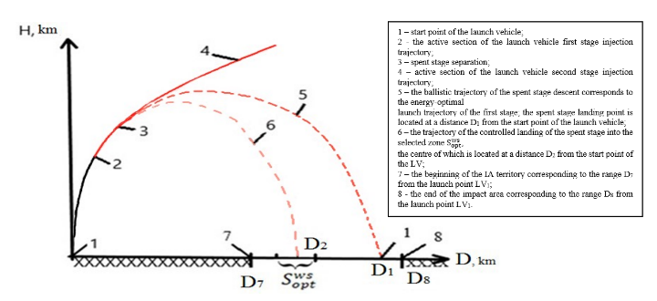~~

**Figure 3.** Optimization of the spent stage flight path within the framework of the controlled descent concept

Traditional ground impact zones at the Baikonur Cosmodrome are characterized by large spatial extent, uncertain landing dispersion, and insufficient consideration of environmental vulnerability. This leads to recurring risks of soil and vegetation damage, potential contamination with residual rocket fuel, and the need for costly rehabilitation.

Previous studies [8–13, 36, 41, 44] have mainly focused on the ballistic and technical aspects of LV separation, with particular attention to trajectory control and flight safety. However, relatively few studies have addressed the integration of environmental sustainability and resilience into the design of impact zones [49-50]. The lack of such integration creates a methodological gap between aerospace engineering models and environmental safety management.

The conceptual framework of this study combines geoinformation analysis, remote sensing of the Earth (RSE), and environmental stability modeling into a single information and analytical system. This system allows for the automatic identification of environmentally stable zones for controlled descent based on quantitative spatial data, rather than expert assessment alone.

Accordingly, the study is guided by the following objectives:

- formalization of environmental and geotechnical criteria related to the assessment of environmental stability in areas affected by LV;

- design of a modular IAS architecture that combines RSE and GIS data sets with multi-criteria ranking procedures;

- Development and testing of a technological process for spatial assessment and classification of the stability of operational-territorial units (OTUs) within selected areas of Baikonur's impact;

- Assessment of the methodological applicability of the IAS for future environmental safety planning at other domestic spaceports.

Research questions arising in connection with this concept include:

- How can environmental and geotechnical parameters be converted into formalized criteria suitable for quantitative assessment of the sustainability of natural complexes in rocket stage fall zones?

- How can the modular architecture of the IAS combine heterogeneous remote sensing and GIS data with multi-criteria ranking methods to provide a reproducible assessment of the environmental stability of territories?

- How can multi-source geospatial data be integrated into a single process for assessing and classifying the environmental sustainability of the Baikonur Cosmodrome launch sites?

- To what extent can the developed IAS be adapted and applied to ensure environmental safety when designing fall zones at other domestic spaceports?

Traditional trajectory design methods are mainly based on ballistic dispersion modeling and safe distance calculations, where environmental factors are considered secondary or post-event considerations [41]. Consequently, potential landing areas are determined primarily by geometric criteria, while environmental vulnerabilities such as vegetation resilience, soil sensitivity, or the risk of water migration of toxic rocket fuel remain unquantifiable.

This study presents a proactive approach to environmental planning that incorporates ecosystem resilience parameters directly into the decision support process for controlled descent (see Figure 3).

The conceptual and methodological assumptions outlined above formed the basis for the development of the IAS, its data structure, and the analytical procedures used.

**3. Materials and methods**

The methodological basis includes a combination of ballistic modeling, geoinformation analysis, and assessment of the ecological sustainability of territories.

The architecture of the information and analytical system (IAS) combines diverse spatial data (vegetation, soil, relief, hydrology, meteorological parameters) into a single platform for calculating and visualizing areas of environmental sustainability.

The structure of the information and analytical system (IAS) consists of four interconnected subsystems:

1) A GIS database storing spatial and attribute data;

2) An “Accuracy” database including ballistic modeling parameters and dispersion ellipses;

3) A “Toxicity” database describing the potential chemical risks from fuel residues;

4) An “Eco-passport” database aggregating indicators of the environmental condition of the impact area for authorized bodies (the Ministry of Ecology and Natural Resources of the Republic of Kazakhstan).

The schematic structure of the IAS for the impact area (IASia) is shown inFig. 4.

~~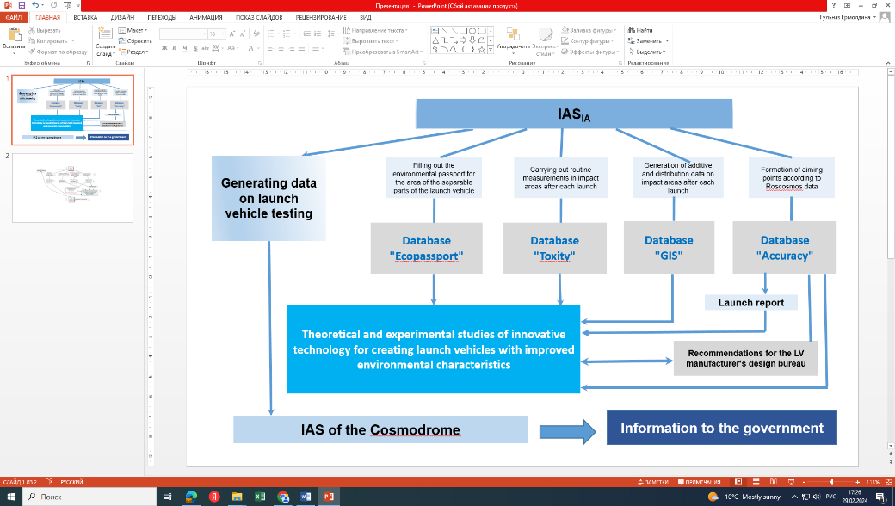~~

**Figure 4.** Optimization of the flight path of the spent stage within the framework of the controlled descent concept

The conceptual model of IASia (illustrated in Fig. 4) includes four interconnected subsystems: GIS database, accuracy database, toxicity database, and eco-passport database.

Together, these components create a modular structure that allows engineering, geographical, and environmental factors to be considered jointly in a single computing environment (Fig. 5).

~~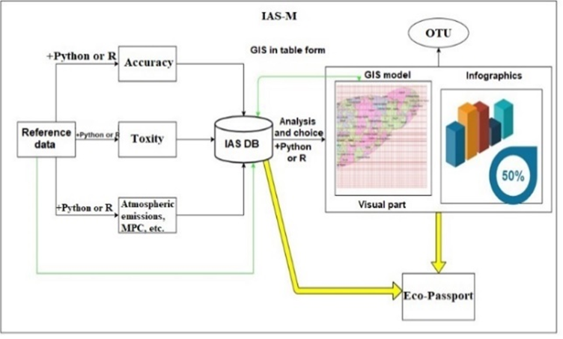~~

**Figure 5.** IAS architecture of LV stage landing zones

Optimization of the spent stage drop zone – the focus of our research – is stored in the GIS database.

Methodologically, the GIS database combines several thematic layers: vegetation condition, soil mechanical strength, soil ecological quality, and relief-hydrological stability. Each of these contributes to the overall assessment of OTU sustainability, forming the basis for a balanced multi-criteria analysis that supports both environmental assessment and operational planning.

The IAS data processing hierarchy is schematically represented in Figure 5, which shows the flow of information from input datasets and pre-processing modules through thematic layer generation to final decision maps.

Given the nature of the negative anthropogenic consequences of rocket operation and the need to certify each fall zone [46], the design of these landing points with stable ecosystem characteristics should be based on the following provisions:

1) limiting the dispersion zone and the nature of the scattering of spent stage fragments by a calculated ellipsoid;

2) using GIS technologies to create a data array for the impact area;

3) determining the calculated indicators of environmental sustainability;

4) taking into account seasons and meteorological (climatic) conditions;

5) determining the purpose of economic activity in the area of distribution and adjacent territories;

6) determining the presence of specially protected natural areas and aquatic ecosystems;

7) determining the presence of populated areas to exclude threats to human life and health;

8)consideration of terrain relief to minimize the migration processes of rocket propellant components (RPC);

9) taking into account the presence of water bodies to exclude the migration of toxic fuel components;

10) taking into account technical and technological aspects to ensure the availability of transport routes, infrastructure for servicing and clearing areas, as well as the possibility of safe and effective processing, collection, and transportation of rocket parts;

11) determining environmental (economic) damage.

To address the issue of environmental safety at these rocket stage landing sites, it is necessary to identify the characteristics of ecosystem resilience and vulnerability to the impact of liquid-fuel launch vehicles.

The parameters of the stability and vulnerability of ecosystems (biogeocenoses) consist of the stability parameters of the main components: soil, water, and vegetation cover.

Therefore, to ensure environmental safety, it is necessary to take into account the factors of ecosystem stability in the landing area:

a) meteorological factors and vegetation flammability;

b) changes in soil quality, as well as deterioration of fertility and degradation;

c) the state of vegetation cover;

d) the presence of watercourses and the type of economic activity.

The general sequence of the study includes the following main stages:

- collection and systematization of initial data;

- modeling or operating with existing ballistic dispersion ellipses for selected types of missiles;

- zoning of the territory and formation of operational-territorial units (OTU);

- calculation of environmental sustainability indicators: state of vegetation (QVi), fire hazard assessment (QFi), soil strength (QSi), soil cover quality (QBi), terrain relief (Qrelief);

- ranking of zones by degree of environmental sustainability;

- interpretation of results and formulation of proposals for environmentally safe planning.

IAS combines diverse geospatial datasets to assess environmental stability in rocket launch fallout zones. Open and national geospatial data sources were used to conduct the study:

- Multispectral satellite imagery: Sentinel-2 Level-2A scenes (2017–2023) covering the growing season (May–September);

- Digital elevation model: ASTER GDEM v3 with a spatial resolution of 30 m for analyzing slopes, exposure, and hydrographic networks;

- Soil and environmental maps: datasets from the national digital soil and environmental survey at a scale of 1:200,000;

- climate and reference data (including seasonality);

- topographic and hydrographic layers: digitized from official maps and verified using remote sensing to refine contours, economic and water features;

All data sets were converted to UTM Zone 43 N (EPSG: 32643) projection and harmonized in terms of spatial resolution to ensure consistency between IAS modules. The study area is drop zone No. 15, 25 in the Ulytau district of the Karaganda region. The fall area has the shape of a double ellipse superimposed on each other. The geographical extent of the study area and its topographic base are shown in Figure 6.

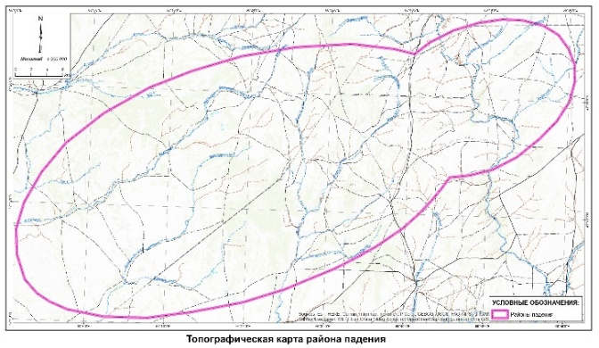

**Figure 6.** Topographic map of the area of impact No. 15.25 with the boundaries of the study area highlighted

Cartographic processing and visualization were performed in ArcGIS 9.3.

To ensure comparability and analytical correctness, the following preprocessing steps were applied to the input data:

atmospheric and radiometric correction of Sentinel-2 imagery;

cloud masking and generation of seasonal NDVI composites;

smoothing of temporal series (seasonal averaging for 2017–2023);

spatial resolution normalization (30 m × 30 m);

boundary clipping to the Yu-24 zone (Impact Areas No. 15 and No. 25);

creation of a regular (or irregular) analytical grid of 1 × 1 km (OTU), matching the boundaries of the study area.

Each grid element was assigned a unique identifier, which serves as a key for linking all thematic layers within the IGD geospatial database. The methods used are based on open sources and standards. Access restrictions apply only to operational field observations within the closed areas of the Yu-24 zone.

*3.1 Determination of impact zones*

The determination of rocket launch vehicle (LV) impact zones is a fundamental step in the development of the Information and Analytical System (IAS).

This stage provides a link between ballistic trajectory modeling and ecological and geospatial analysis, forming a spatial framework on which all subsequent ecological and economic assessments are performed.

The most important aspect of justifying the choice of landing sites should be to minimize the negative impact on the environment and the population of adjacent territories [65].

Analysis of various cases of spent rocket stages landing in designated areas indicates the local nature of the impact of launches and differences in the intensity of the negative load on individual areas.

Ballistic fall zones are calculated using the Monte Carlo method, taking into account variations in stage separation parameters: height, angle of inclination, velocity vector, and aerodynamic drag [41]. For the Proton rocket, statistical dispersion ellipses are used (see Fig. 3). These ellipses are loaded into the IGD and used as spatial boundaries for assessing environmental parameters within the probable fall zones.

This approach to modeling provides a statistically reliable basis for determining fall zones under nominal launch conditions.

The orientation of the ellipses was tied to the flight azimuths of representative Proton launch trajectories, which ensured that the spatial model corresponded to actual operating conditions. The dispersion ellipses were imported into the IAS GIS database and overlaid on topographic and environmental datasets (vegetation, soil, relief, hydrology).

This integration allows automatic extraction of environmental parameters for each potential landing point and supports subsequent ranking of OTUs by stability and risk.

Each ellipse was referenced to the Baikonur coordinate system and divided into an irregular or regular grid. In this case, the grid corresponds to OTU cells (1 × 1 km). For each cell, IAS records the probability of its belonging within the impact ellipse, which allows for the subsequent calculation of area-weighted environmental indices.

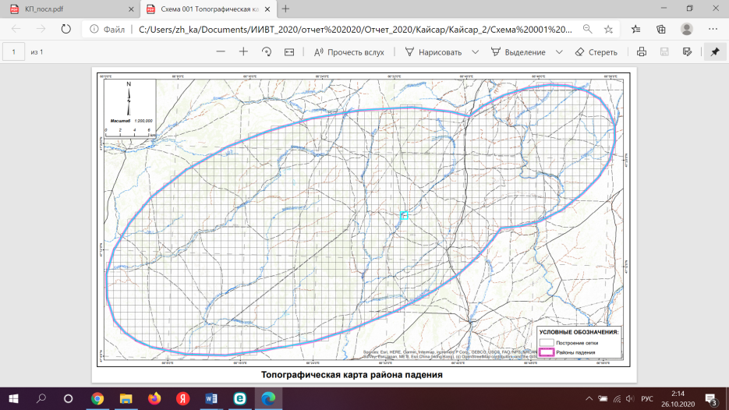

Figure 7. Creation of a grid from 1000 × to 1000 m to delineate OTU within the affected area

This spatial quantitative assessment links the probability of mechanical impact with environmental sensitivity, forming a unified assessment area for controlled descent planning.

Through this integration, the system transforms purely mechanical trajectory data into geo-ecological planning information, ensuring that flight safety and environmental stability are assessed within a single analytical framework.

3.2 Determination of sustainable OTUs

Determining the most suitable OTU types involves the following steps [44, 52]:

1) A rectangular coordinate grid of n sections is superimposed on a topographic map of the study area of the proposed impact zone. Each section has a specific area of dimension Si and a unique ecotope composition (including soil and subsoil type, vegetation type, presence of water sources, etc.). It is also possible to rank the territory based on an irregular grid.

2) Based on reference and normative indicators, topographic and thematic maps, Earth remote sensing data, inventory data from environmental passports, and methods for environmental assessment of territories [9], a database is created to evaluate the values of the specified criteria.

3) Determination of vegetation cover sustainability. Vegetation data were obtained from Sentinel-2 images after radiometric and atmospheric correction. Image selection criteria included cloud cover ≤ 10%, temporal consistency during the growing season, and minimal atmospheric artifacts.

NDVI was calculated from the red (R2, 665 nm) and near-infrared (R1, 842 nm) bands using the standard expression:

$NDVI=\frac{R_{2}-R_{1}}{R_{2}+R_{1}}$ (1)

For each OTU, average NDVI values were extracted from seasonal composites using variance-elliptical masks (see Fig. 8).

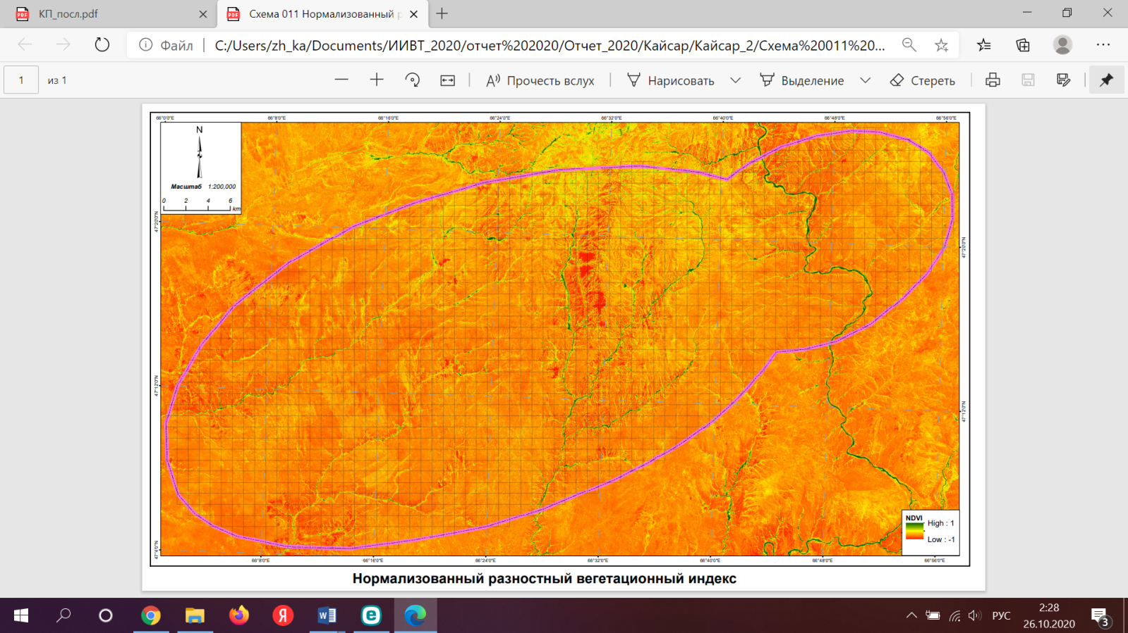

**Figure 8.** Normalized difference vegetation index

Then, multi-year composites (2017–2023) were averaged to reduce interannual variability, which allowed us to obtain a “baseline vegetation” layer for IAS analysis.

4) Determination of soil quality and mechanical strength

Soil parameters were obtained from the national soil and environmental map and converted into two indicators:

1) Soil quality index (QBi): calculated in accordance with the bonitet classification, normalized to a reference humus content of 7% in the 0–50 cm layer and adjusted for salinity, structure, and erosion factors [48].

2) Soil strength index (QSi): derived from lithological descriptions and texture classes according to the Protodyakonov scale (GOST 21153.1–75).

Mixed soil polygons crossing several OTUs were resolved by area-weighted averaging of the corresponding attributes. All parameters obtained were rasterized and recalculated to an accuracy of 30 m to match other IAS input data. Detailed results and spatial representations are presented (Figure 9).

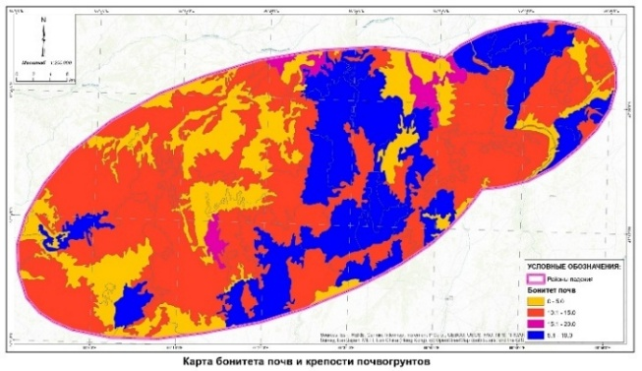

**Figure 9.** Soil quality and fertility map

The composite map shows how the modeled impact areas intersect with different types of ecosystems-steppe grasslands, shrub communities, salt marshes, and dry valleys.

This overlay provides a spatial understanding of which landscape components are most vulnerable to potential disturbance.

In areas where the ellipses intersect with surface water bodies or hydrologically active depressions, additional restrictions were imposed on the choice of planting sites, as these features significantly increase the risk of pollutant migration.

Similarly, areas containing dense or recovering vegetation cover were marked as environmentally sensitive, while degraded or sparsely vegetated areas were considered potentially stable under controlled descent scenarios. This integration ensures that both physical (size, shape, orientation) and ecological (type of soil and vegetation cover, slope, hydrological conditions) characteristics are available for multi-criteria assessment.

Thus, geometric and ecological characteristics serve as a link between the ballistic model and the ecological analysis module. This allows IAS to translate the geometry of physical dispersion into quantitative environmental indicators, forming the basis for assessing the stability and ranking of OTUs.

**4.** **Research results**

The research was conducted within the Yu-24 impact zone (impact zones No. 15 and 25) located in the Ulytau district of the Karaganda region, Republic of Kazakhstan.

This area is one of the most studied impact zones for Proton rocket stages launched from the Baikonur cosmodrome.

The region is characterized by slightly undulating steppe plains with absolute heights ranging from 200 to 400 m above sea level, interspersed with shallow depressions and ephemeral streams.

The landscape consists mainly of dry steppe vegetation on chestnut and light chestnut soils with local manifestations of saline and saline complexes.

In climatic terms, this area belongs to the arid continental belt, experiencing strong seasonal contrasts – hot, dry summers and cold winters, which greatly affect vegetation productivity and susceptibility to fires. The spatial extent of the selected study area and its topographic context are shown in Figure 7.

This figure shows the administrative boundaries, hydrographic network, major landmarks, and coordinate grid used for spatial referencing of all subsequent data sets. Each OTU acts as a separate analytical cell for which all ecological and engineering-geological parameters were calculated. This grid structure ensures compatibility between data with different spatial resolutions and allows for automated statistical extraction of indicators in the IAS environment. The grid was formed using the Baikonur coordinate system (UTM Zone 43 N, EPSG: 32643) with subsequent referencing to the topographic base map.

*4.1. Zoning and formation of OTUs*

The delineation of operational-territorial units is the spatial basis for integrating the results of ballistic modeling, remote sensing analysis, and environmental assessment within the IAS. At this stage, a consistent analytical grid is created, allowing for quantitative comparison of diverse environmental parameters. The OTU was designed in accordance with the principles of spatial homogeneity and functional relevance.

Each OTU is an elementary landscape-analytical unit characterized by uniform features of relief, soil, and vegetation. The zoning scheme takes into account:

- the boundaries of dispersion ellipses obtained by Monte Carlo modeling;

- the main landforms and drainage lines obtained from a digital elevation model;

- the boundaries of soil cover and soil extracted from thematic maps.

These criteria ensure that each OTU corresponds to a discrete combination of natural-geographical and anthropogenic factors affecting the stability of potential planting sites.

*4.2. Assessment and classification of OUT*

*4.2.1 Vegetation and fire safety (QVi, QFi)*

Vegetation is a key indicator of environmental stability in impact zones. Its condition reflects the ecosystem's ability to withstand and recover from mechanical and pyrogenic impacts caused by falling launch vehicle fragments. Within the IAS, vegetation parameters are represented by the vegetation stability coefficient (QVi), obtained from Sentinel-2 multispectral images processed for the 2017–2023 growing seasons.

After radiometric and atmospheric correction, multi-temporal composites were obtained for different phenological stages, allowing for the assessment of seasonal and interannual variability. The normalized difference vegetation index (NDVI) was calculated using the red (665 nm) and near-infrared (842 nm) channels.

For each OTU, NDVI statistics were extracted from raster composites using the OTU grid. Spatial NDVI maps illustrating vegetation density and vitality are presented in Figure 8. NDVI data were classified into five qualitative categories, ranging from sparse or degraded vegetation to dense perennial grass-shrub communities. This classification served as the basis for assigning QVi scores to individual OTUs.

According to the thematic zoning (Fig. 8), areas with sparse or intermittent vegetation cover are the most resilient, which is associated with their adaptation to extreme conditions and lower biomass. In contrast, areas with dense grass and shrub vegetation are more vulnerable to mechanical impact.

In addition to vegetation analysis, fire safety (QFi) is proposed to be taken into account, characterizing the potential for ignition and fire spread within the same spatial framework. For this purpose, the input layer is the density of projective cover and the amount of biomass obtained from NDVI and soil and vegetation cover maps (Fig. 10).

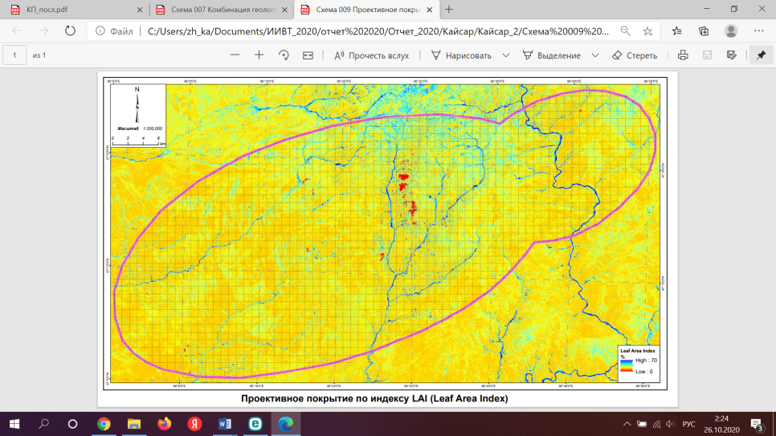

**Figure 10.** Projected coverage in accordance with LAI (Leaf Area Index)

Areas with high NDVI values, low moisture retention, and prolonged exposure to drought were identified as potentially high-risk zones, while areas with sparse vegetation or hydrologically buffered areas were classified as low-risk zones.

The resulting spatial distribution of fire hazard categories is shown in Figure 11.

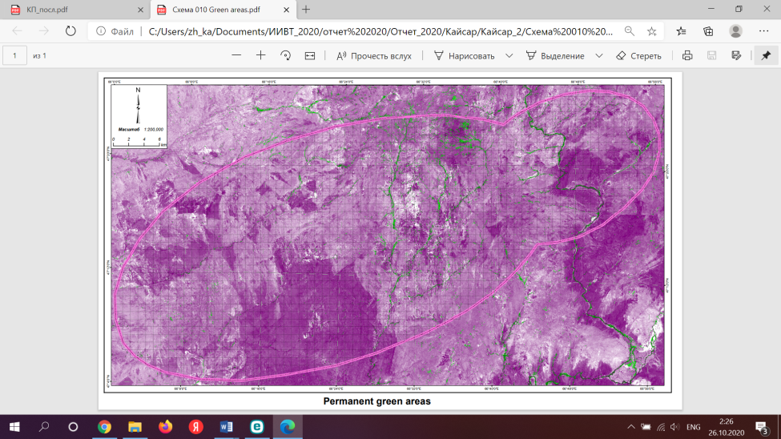

Figure 11. Areas of stable vegetation

Vegetation (QVi) and fire safety (QFi) coefficients were stored as thematic layers in the IAS geodatabase. Each OTU record contains the average NDVI value, the dominant vegetation class, and the corresponding fire hazard category. Together, these indicators characterize the bioecological stability of the territory: dense, moisture-balanced vegetation increases stability, while highly combustible biomass increases pyrogenic vulnerability.

Thus, the combination of the QVi and QFi layers provides a balanced understanding of how vegetation affects the stability and susceptibility of ecosystems in impact zones. Their comprehensive assessment is the first component of a multi-criteria model of environmental stability.

*4.2.2. Soil quality and mechanical strength (QSi, QBi)*

Soil cover within the study impact zone is one of the key factors determining the mechanical strength and ecological sensitivity of the landing surface. Soils act as a buffer against mechanical deformation and chemical contamination; their properties directly influence the degree of recovery after rocket stage impacts.

Within the IAS, soil conditions are represented by two complementary indices: the ecological quality coefficient (QBi) and the mechanical strength coefficient (QSi).

Ecological quality (QBi) was determined using the bonitet (fertility) classification system approved by the Ministry of Agriculture of the Republic of Kazakhstan [48]. For each OTU, soil characteristics were extracted from a digital soil and environmental map (scale 1:200,000), which includes information on humus content, granulometric composition, salinity, carbonate accumulation, and degree of erosion. These parameters are normalized relative to a reference humus content of 7% in the 0–50 cm layer and adjusted by correction factors for mineralization, structure, and thickness of the humus horizon. The resulting QBi values describe the relative fertility and ecological stability of soils within each OTU.

Differentiation of soil types (and soil substrates) is the most common type of engineering calculation. To create a block for assessing the degree of mechanical impact of SRM on various OTUs, the quantitative determination of soil cover diversity is carried out on the basis of digital maps at a scale of 1:200,000 — soil and soil-ecological zoning, taken from the ecological passport of the fall area (Figures 12-13).

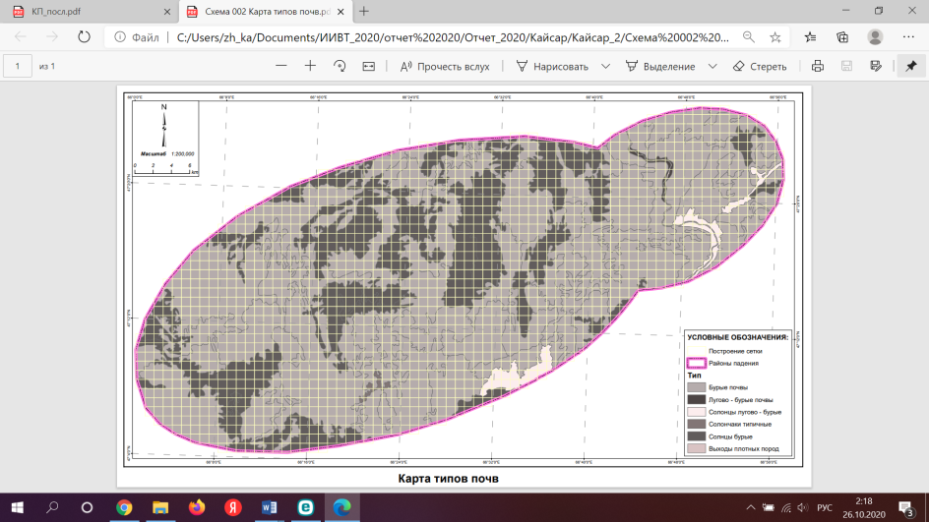

**Figure 12.** Soil type map

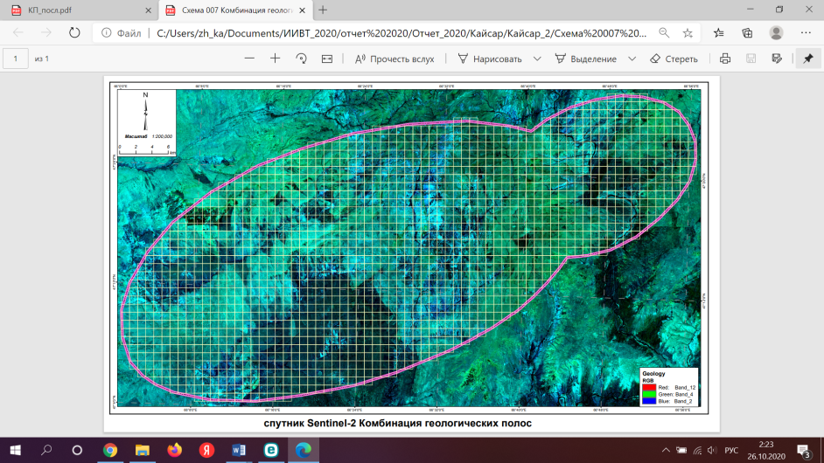

Figure 13. Combining geological bands based on Sentinel-2 data to refine soil map contours

The digital soil map contains information about soil cover and parent rock. The digital map of soil and ecological zoning uses a multi-stage taxonomic system for dividing the territory. Calculations are performed at the lowest level of soil and ecological zoning — within the boundaries of the catchment areas — in the MapInfo program using the area-weighted average method (Figure 13). The resulting map allows us to identify OTU with the percentage ratio of predominant soil types. If digital maps are available for the study area, the input data for it is calculated using a geoinformation application based on ArcView GIS with Spatial Analyst and 3D Analyst extensions.

The soil cover is characterized by different soil types with different physical and chemical properties. Therefore, it seems appropriate to process the data based on a soil map with already known reference data. The assessment and grading of soil characteristics includes the determination of soil bonitet (value) in accordance with standard sorting methods.

The mechanical strength coefficient (QSi) reflects the ability of the base to withstand mechanical stress without irreversible deformation. It was assessed based on the texture and lithological composition of the soil obtained from the same soil and environmental database and the geological layer of the foundation integrated into the IAS. The classification is compiled according to the Protodyakonov strength scale (GOST 21153.1–75) and distinguishes between stable loamy-clay formations and weakly structured sandy and saline bases.

Each soil polygon was assigned a relative stability class, and area-weighted average values were calculated for OTU cells intersecting several soil types. The resulting QSi map (Fig. 15) highlights areas of increased mechanical stability, primarily corresponding to compact loamy soils in the northern and central parts of the study area.

The QSi and QBi layers were combined to obtain a composite soil stability index representing both the physical and ecological aspects of substrate stability. This integrated layer (see Fig. 9) illustrates the spatial differentiation of soil conditions in the impact zone and provides a significant contribution to the overall assessment of OTU stability.

Areas with strong, well-structured soils are considered to be the most stable in terms of mechanical impact and, therefore, more preferable for the fall of step fragments. In contrast, areas with high bonitet indices, characterized by valuable and productive soils, although ecologically stable, are considered more economically vulnerable because their restoration after impact requires significantly higher costs. Degraded, salinated, or loose substrates with low mechanical strength and high ecological sensitivity are identified as areas where rockfall should be avoided or special measures should be taken to prevent and minimize damage.

All soil indicators obtained are stored in the IAS relational database and linked to the corresponding OTU identifiers for analysis of soil parameters in combination with vegetation, fire hazard, and relief characteristics in a multi-criteria environmental assessment.

*4.2.3. Relief (Qrelief)*

The morphology of the terrain has a strong influence on both the mechanical distribution of impact energy and the response of the environment to disturbances. Slope gradients and curvature determine the nature of surface runoff, soil erosion potential, and local accumulation of pollutants released after stage separation. Therefore, topography is a critical factor in assessing the environmental sustainability of OTU.

Topographic analysis is performed using the ASTER Global Digital Elevation Model (GDEM, V3) with a spatial resolution of 30 m. From this DEM, slope, exposure, and curvature layers are obtained in IAS using the Spatial Analyst module. The resulting digital elevation model (Figs. 14-15) illustrates the main landforms in the Yu-24 impact area, ranging from gentle undulating plains to localized ridges and depressions.

A surface exposure map (Fig. 16) is created to assess the potential effects of solar heating and drying, which affect the moisture balance of vegetation and susceptibility to fires. Areas with southern and western exposures tend to be drier and more prone to erosion, while northern slopes and concave shapes tend to retain moisture and demonstrate greater ecological stability.

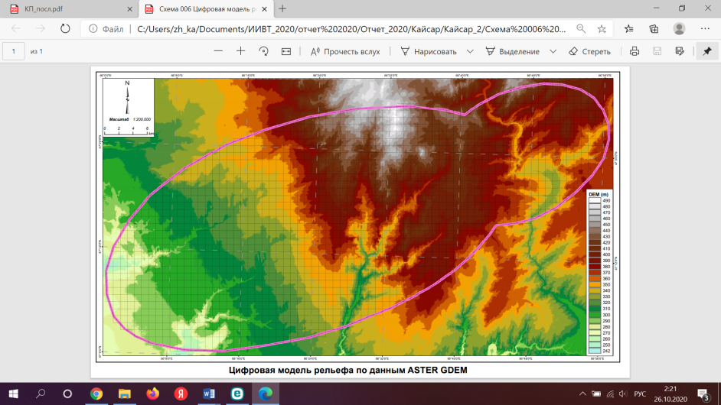

Figure 14. Digital elevation model based on ASTER GDEM data

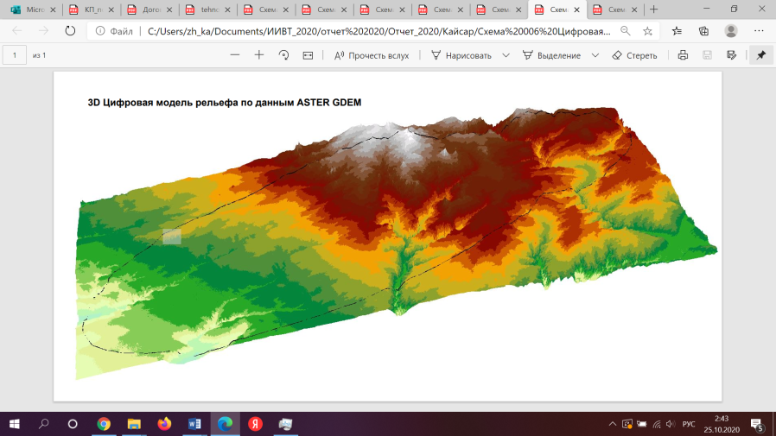

Figure 15. Digital 3D relief model based on ASTER GDEM data

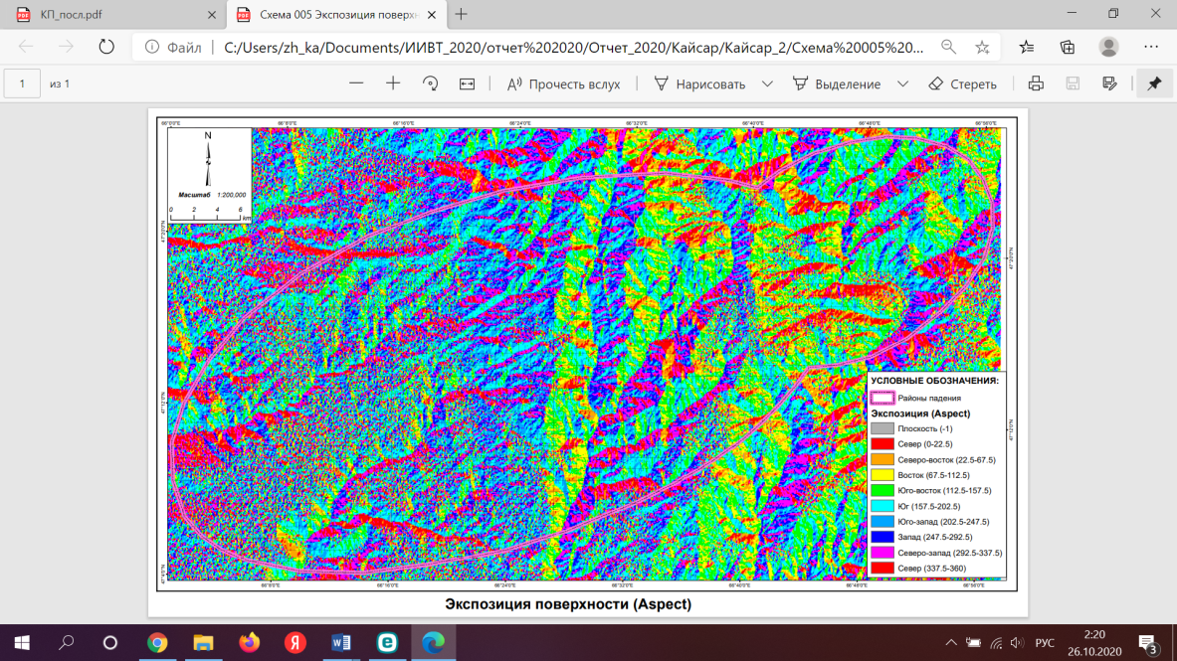

Figure 16. Surface exposure (exposure)

Hydrological structures are extracted from the same DEM using runoff accumulation algorithms and supplemented by manual digitization of watercourses and depressions on topographic maps. This process allows the identification of intermittent channels, ephemeral watercourses, and shallow basins prone to seasonal flooding. The resulting hydrographic network is verified against high-resolution Sentinel-2 images and integrated as a separate vector layer in the IAS.

Special attention is paid to areas where the dispersion ellipses intersect with hydrologically active features such as river valleys or depressions. These intersections are classified as hydrologically sensitive sectors, as potential chemical pollution in these areas can spread along runoff paths and affect larger ecosystems downstream.

The Qrelief parameter is obtained by integrating slope, curvature, exposure, and hydrological density within a standardized OTU grid.

Weighting factors are proposed for each factor to reflect their relative impact on stability: steeper slopes and concave shapes reduce the stability rating, while balanced gradients and well-drained profiles increase it. Stable areas, characterized by moderate slopes and low hydrological connectivity, dominate the northern and central parts of the zone, while unstable areas—typically steep or poorly drained depressions—are concentrated along local valleys. This differentiation provides important input for determining environmentally safe planting sites.

Thus, the Qrelief index represents a terrain relief modifier in the overall environmental sustainability model.

*4.3. Integrated assessment and ranking of OTUs*

To summarize the results of the previous analysis, all environmental indicators — vegetation condition (QVi), fire safety (QFi), soil mechanical strength (QSi), soil ecological quality (QBi), and relief-hydrological stability (Qrelief) — are integrated into the IAS structure to obtain a composite environmental stability index for each OTU. The integration procedure follows the logic of weighted superposition, ensuring that indicators with different measurement scales are converted to a common normalized range (0–1).

The overall OTU sustainability index is proposed to be calculated using the following formula:

$Q_{{OTU}_{i}}=\left(k_{V_{i}}Q_{V_{i}}+k_{S_{i}}Q_{s_{i}}+k_{B_{i}}Q_{B_{i}})*(±Q_{relief}\right)$ (2)

where — summary assessment of the stability of the operational-territorial unit, k — normalized weight coefficients of the dominant component of the ecosystem (plant community, soil type, soil), representing the relative influence of each factor, Qrelief — criterion for the presence or absence of a water body and the possibility of potential migration of rocket fuel.

To determine the costs required to restore an operational-territorial unit with an area of Si, the area of damage caused by fire, the fire hazard index is multiplied by the restoration cost coefficient:

$C_{F_{i}}=k_{F}*Q_{F_{i}}$ (3)

The rock strength scale [51] is used to calculate the soil strength criterion. For each OTE, the proportion of rocks of different strengths (in percent) is determined, each rock Qp is assigned a weight coefficient, and then the weighted average value is calculated:

$Q_{si(сред)}=k_{1}Q_{р1}+k_{2}Q_{p2}+k_{3}Q_{p3}+…+k_{n_{i} }Q_{pn}$ (4)

where n is the number of species present in the Si selected area.

The weighing scheme is derived based on expert assessment calibrated according to literature data on ecosystem resistance and engineering stability [36, 44].

For the criterion, the estimated cost of restoration is determined, and then the costs of eliminating damage related to soil strength characteristics are calculated:

$C_{Q_{p_{i}}}=C_{p_{i}}\sum{k_{n_{i}}}Q_{{np}_{i}}$ (5)

The indicator reflecting the ecological quality (bonitet) of soils is calculated similarly to formulas (3) and (5). The cost of damage restoration according to this criterion is expressed as:

$С_{B_{i}}=C_{B_{n_{i}}}\sum{k_{Bi}Q_{Bni}}$ (6)

The main reactions of vegetation cover to the fall of PH fragments are: a reduction in the projective cover of the soil by plants, up to the complete destruction of the vegetation cover; the death of plants as a result of mechanical impact, fires, and rocket fuel spills; the replacement of dominant and subdominant species with low-productivity communities, etc. [10]. When assessing the state of vegetation cover, an ecosystem approach is used, in which the most important indicators characterizing the degree of disturbance and transformation of vegetation are the parameters of projective cover and species composition. Traditional methods of geobotanical research are used as a methodological basis: description of phytocenoses and spatial distribution of vegetation structure, its relationship with other components of the ecosystem.

The indicator characterizing the state of vegetation cover is determined by the indicators of phytomass and projective cover:

$Q_{V_{i}}=n_{V_{i}}Q_{{Vm}_{i}}Q_{{PC}_{i}}$ (7)

where is the weight coefficient determined according to the dominance of the dominant species in the plant community.

Additionally, an indicator is introduced that reflects the rate of ecosystem recovery after mechanical or pyrogenic impact (in points), which is refined as monitoring data accumulates.

Accordingly, the cost of restoration work on vegetation cover is determined as:

$C_{V_{i}}=n_{V_{i}}Q_{{Vm}_{i}}v_{r_{i}}C_{{nV}_{i}}$ (8)

The total cost of restoring the area Si caused by the listed impacts is determined by summing expressions (3), (5), (6), and (8):

$C_{\sum{i}}=C_{S_{i}}+C_{Q_{Pi}}+C_{Q_{Bi}}+C_{Vi}$ (9)

The optimal zone or OTU area is selected based on the criterion of minimizing total restoration costs.

The economic value (C) of each OTE is calculated as follows:

$С_{impact OTU}=C_{{OTU}_{1}}+C_{{OYU}_{2}}+C_{{OTU}_{3}}+…+C_{{OTU}_{n}}$ (10)

The main essence of the site selection method is to calculate the total criterion for each territorial unit based on source maps, attribute and reference information.

For each site, the sum of measures (∑(QF (Qf) + Qs + Qsк + Qvpс + Qvc)) of influencing factors falling within the site boundaries is calculated and its estimated value is given.

The territory zoning model is presented in a raster format, in which the economic value and fire resistance of each site are determined and points are assigned in accordance with the developed scoring system. Part of the process is automated by integrating Earth remote sensing data and a geographic information system (cartographic material and corresponding tools).

As a result of applying this methodology, it is possible to significantly reduce the area of the fall zone and increase its functional significance.

The economic efficiency of the proposed methodology is justified by the man-made damage caused to natural ecosystems and the restoration of the biological productivity of disturbed areas.

A schematic representation of the integration workflow is shown in Figure 17, illustrating the flow of data from thematic indicators to the composite stability map.

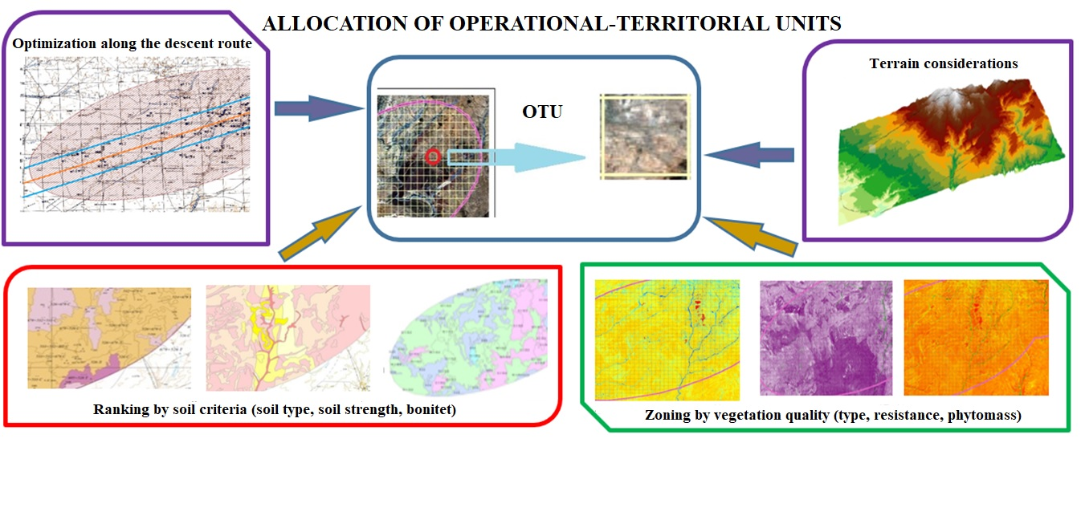

Figure 17. Algorithm for determining OTU

The composite map obtained is then reclassified into four categories of stability based on quantile thresholds:

1) High stability – stable areas with favorable vegetation, strong soils, and balanced relief;

2) Moderate stability – stable but requiring monitoring due to partial degradation;

3) Low stability – ecologically vulnerable or erosion-prone areas;

4) Unstable areas – areas combining steep slopes, saline or poor soils, and degraded vegetation cover.

Each OTU is assigned a stability class, recorded in the IAS attribute table, and color-coded on the final output map. The spatial distribution of these ranked OTUs across the Yu-24 impact area is shown in Figure 18. The figure shows the resulting ecological zoning, which identifies potential landing sites characterized by minimal ecological risk.

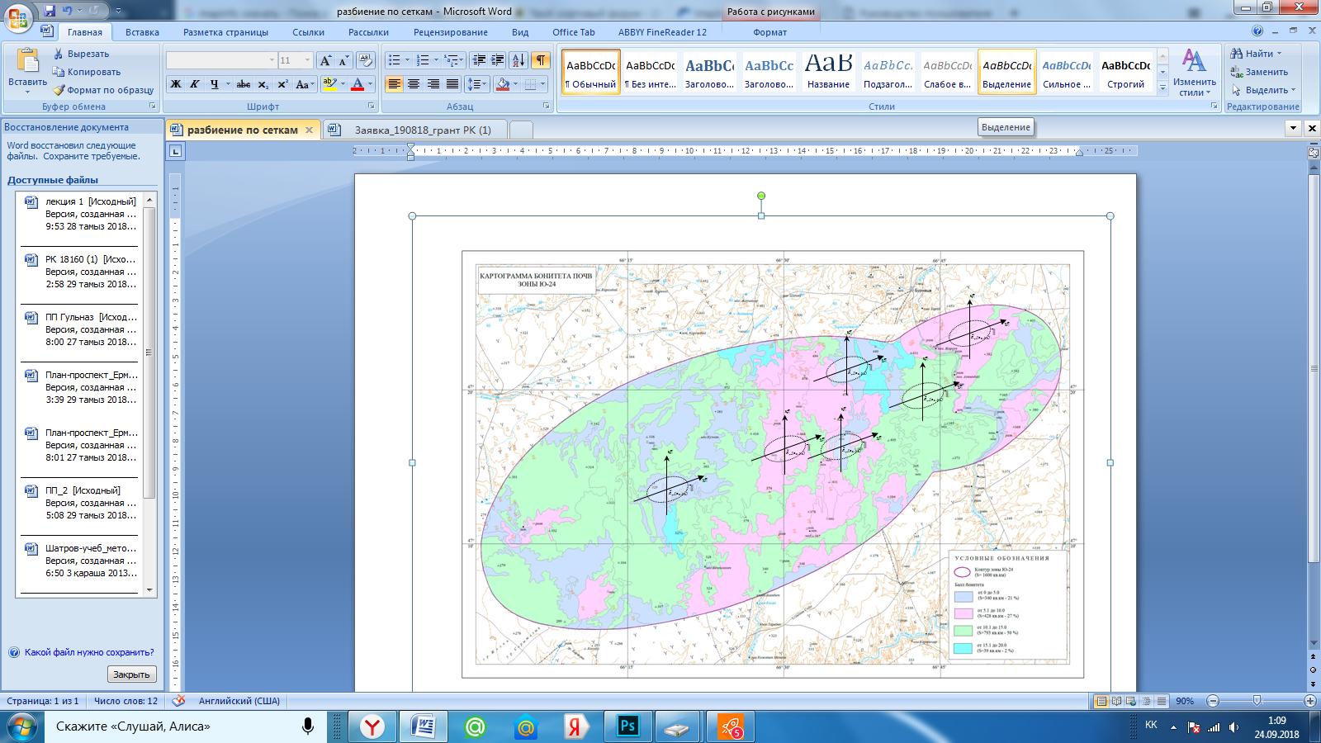

**Figure 18.** Recommended OTUs.

Analysis of the integrated sustainability map shows clear spatial differentiation. The northern and central sectors of the impact zone demonstrate the greatest sustainability, associated with dense steppe vegetation, loamy soils, and gentle relief. Conversely, the southern and eastern parts show less stability due to the prevalence of saline soils, poorly structured soils, sparse vegetation, and proximity to hydrological depressions. These areas are classified as environmentally vulnerable and are recommended for exclusion from potential landing trajectories or for the application of mitigation measures.

Spatial consistency demonstrates the practical value of integrating environmental data directly into runway design procedures.

The final stage of the analysis consisted of combining all previously calculated environmental and geotechnical indicators — QVi, QFi, QSi, QBi, and Qrelief — into a single OTU assessment framework.

The integration is performed within the IAS, which aggregates all spatial layers and applies a standardized ranking algorithm.

The methodological basis for integration is a composite stability model (equation 1), in which the total stability of each OTU is determined as a function of the specified parameters and their corrective weighting coefficients.

OTUi = (Qvegetation + (Qsoils * B)) * (± Qrelief) (1)

The algorithm takes into account the interdependence of ecosystem components: for example, the stabilizing effect of dense vegetation can be offset by steep slopes or weak soils, while high soil stability can compensate for partial vegetation degradation.

All normalized input layers (QVi, QFi, QSi, QBi, and Qrelief) are imported into the IAS raster data processing environment and combined using a sequence of weighted overlay operations. The resulting integrated map of sustainable OTU displays spatial differentiation across the entire impact zone, highlighting the most ecologically stable and least disturbed areas.

5. Discussion

The results presented in Section 4 demonstrate that the developed IAS provides a practical and quantitative basis for optimizing the ground fall zones of launch vehicles at the Baikonur Cosmodrome.

The developed methodology demonstrates its effectiveness through a structured and reproducible workflow that combines engineering and environmental criteria into a single analytical framework. Rather than relying on numerical results, its value lies in the coordination and logical integration of multiple spatial, environmental, and technical data sets to ensure environmentally sound decisions are made at the earliest stages of planning.

Compared to traditional approaches that define impact zones solely by trajectory and safety limits, the proposed IFRS-based framework introduces environmental sustainability as a determining factor in operational planning. It combines vegetation condition (QVi), soil stability (QSi, QBi), relief (Qrelief), and fire risk (QFi) to identify areas that can absorb or recover from anthropogenic disturbances with minimal long-term degradation.

By synthesizing remote sensing, GIS, and environmental monitoring data, the methodology provides:

- transparent logic for ranking OTUs according to ecosystem sustainability;

- compatibility with existing flight safety and control systems;

- scalability, allowing it to be adapted for other ground-based spaceports outside Baikonur.

From an operational perspective, the system improves the efficiency of environmental decision-making by:

- establishing objective and reproducible criteria for selecting landing zones;

- supporting pre-launch planning and environmental cleanup procedures;

- enabling periodic monitoring and adjustment of landing point coordinates as environmental conditions change.

The methodology thus bridges the gap between engineering optimization and environmental responsibility by creating a functional decision-making support environment that replaces post-launch remediation with proactive sustainable development planning.

The effectiveness of the proposed approach should be considered methodological rather than quantitative—it ensures that environmental safety is embedded in the very logic of launch planning. This integrative design positions IAS as a technological and environmental tool for the sustainable management of launch vehicle fall zones.

Existing international practices for determining rocket launch fall zones are primarily focused on flight safety and aerospace logistics, with limited consideration of environmental parameters. Typical methodologies, such as those used in the United States, the European Union, Japan, India, and Brazil, use trajectory modeling and probabilistic modeling to determine marine or uninhabited land fall zones. These models ensure the safety of populated areas, but rarely assess the vulnerability of the ecosystem in the landing zone. As a result, environmental protection remains reactive, relying on mitigation rather than proactive prevention.

The work [36] illustrates this engineering-oriented paradigm. This work focuses on trajectory management, statistical dispersion, and hazard radius calculation, but it does not include geospatial environmental indicators or data-driven environmental assessment.

In contrast, the methodology presented in this paper integrates environmental sustainability factors into the same decision space traditionally used for flight safety calculations.

The proposed information and analytical system extends the logic of area modeling by incorporating environmental data—vegetation condition (QVi), fire risk (QFi), soil quality (QBi), soil strength (QSi), and hydrological stability of the terrain (Qrelief) — directly into the spatial structure of the impact zone design.

Such integration transforms the decision-making process from a purely mechanical optimization task into a multi-criteria environmental assessment.

The proposed approach differs from previous ones in several key aspects:

- interdisciplinary synthesis combines aerospace trajectory modeling with environmental GIS analysis in a single modular platform;

- quantitative mapping of the environment by assigning normalized sustainability coefficients to discrete operational-territorial units;

- transparency of decision-making — allows you to reproduce and verify the ranking of potential landing sites;

- Adaptability — easy integration of new data sets, indicators, or launch configurations without changing the system architecture.

These innovations allow environmental and technical specialists to work within a common spatial interface, ensuring that environmental safety is considered alongside ballistic feasibility.

The proposed framework is also consistent with the global trend toward sustainable space operations, as emphasized by the UN Committee on the Peaceful Uses of Outer Space (COPUOS) and national regulatory programs in Europe and the United States. Unlike the maritime impact zones used by coastal countries, Kazakhstan and other landlocked countries require land-based solutions that balance launch frequency, public safety, and environmental integrity.

Consequently, the IAS adapts international principles to specific regions, enabling inland launch sites to carry out sustainable flight range planning in line with global policy objectives.

Thus, the approach presented complements and extends existing international methodologies by introducing a reproducible, environmentally sound decision support system. It does not replace traditional safety modeling, but enriches it with spatially explicit environmental intelligence. Thanks to IAS, environmental sustainability becomes an integral part of the engineering design process, rather than an external constraint assessed after launch planning.

This distinction defines the methodological contribution of this study to prevailing international practice.

From a scientific point of view, the work establishes a clear conceptual and computational link between flight safety modeling in the aerospace industry and environmental sustainability assessment.

The proposed IAS architecture provides a verifiable framework for integrating heterogeneous spatial data—remote sensing, digital soil mapping, meteorological, and topographical information—into a coherent decision support system.

From an applied perspective, the methodology provides a framework for adaptive land use management within existing impact zones.

The results obtained emphasize that sustainable space operations require a balance between engineering feasibility and environmental responsibility. IAS demonstrates that these considerations can coexist within a single spatial analysis environment without compromising launch safety or environmental protection.

In summary, the study presents a consistent and verifiable methodology that links data collection, environmental modeling, and decision support into a single workflow.

This confirms the feasibility of integrating environmental sustainability criteria into range planning procedures at ground launch facilities.

The results obtained during the research showed that solving the problem of optimizing impact zones is an original approach in terms of reducing the environmental impact on the biogeocenoses of the rocket launch areas, creating operational reserves of landing points for spent stages, and monitoring these points.

The significance of the research results lies in reducing the technogenic pressure of rocket launches from the Baikonur cosmodrome on landing sites in neighboring countries (Russia, China, Turkmenistan), preserving natural landscapes, natural monuments, specially protected natural areas, preventing fires, and ensuring compliance with the recommendations of international organizations COPUOS and IADC on reducing man-made environmental pollution. The creation of the IAS will make it possible to form a new direction in research on information processing and image recognition, as well as in the development of control systems for launch vehicle onboard systems.

The developed IAS and methodology for predicting the selection of fall areas are highly scalable and can be adapted to other spaceports located in continental areas. In particular, the methodology is applicable for optimizing environmental safety in the fall areas of stages at the following spaceports:

- Russia (Plesetsk, Baikonur (3rd stage fall zones), Vostochny) — the fall zones of the Plesetsk spaceport cover the Arkhangelsk region and the Komi Republic. The fall zones of the Plesetsk, Baikonur, and Vostochny spaceports are located in nine regions of the Russian Federation: the Altai and Perm Territories, the Sverdlovsk, Novosibirsk, Omsk, and Tomsk Regions, and the Republics of Altai, Tyva, and Khakassia. There are a total of 18 rocket stage fall zones in Russia.

- China (Jiuquan, Taiyuan) - falls occur in the Inner Mongolia Autonomous Region, Gansu Province, and the mountainous regions of Shanxi Province.

- India (Satish Dhawan Space Centre) - despite its coastal location, launches into polar orbit are accompanied by the fall of stages onto land within the state of Andhra Pradesh and neighboring regions.

- Iran (Semnan) — an inland and remote spaceport, with stages falling in the mountainous and semi-desert regions of eastern Iran.

- Brazil (Alcântara) — partially coastal, but in the event of deviations, test launches, or non-standard (abnormal) launches, stages may fall on inland territories.

Unlike sea launch sites (e.g., Cape Canaveral, Vostochny for eastern launches, Kourou), where stages fall into the ocean, land-based launch sites place a high burden on ecosystems and require geo-ecological management.

The results of the study contribute to the achievement of several Sustainable Development Goals (SDGs) approved by the UN:

- SDG 9 “Industry, Innovation and Infrastructure” — through the development and implementation of innovative engineering solutions in the field of aerospace infrastructure;

- SDG 11 “Sustainable Cities and Communities” — by minimizing environmental and man-made risks to populated areas in rocket stage fall zones;

- SDG 13 “Climate Action” — by reducing the negative impact of rocket launches on vulnerable ecosystems and improving environmental planning tools.

The development of the proposed IAS contributes to the introduction of environmentally friendly technologies in the aerospace industry and supports the implementation of national sustainable development strategies.

6. Research limitations

Although the proposed IAS methodology and architecture have demonstrated consistency and logical integration, a number of limitations currently restrict their applicability.

For example, the spatial resolution of the base datasets, particularly the 30-meter DEM and 10-meter Sentinel-2 images, limits the accuracy of small-scale analysis in heterogeneous landscapes. This resolution is sufficient for regional planning, but may not capture micro-relief features or small erosion forms that affect local stability.

The analysis was limited to one representative fall area (Yu-24, fall areas No. 15 and 25) within the Baikonur Cosmodrome polygon. Consequently, the conclusions reflect regional geomorphological and climatic conditions and should not be generalized to all internal launch sites without further verification.

The weighting factors proposed for use in the composite stability equation (Equation 1) are based on expert estimates and literature references and are only applicable when ranking by superimposing a regular grid. The analysis is based on multi-year averaged conditions for 2017–2023, which smooth out interannual extremes. Therefore, short-term anomalies such as droughts, storms, or fires are underrepresented in the stability assessment. The integration of environmental data into space launch planning is still in its early stages in national practice. The study did not include legal, procedural, or interagency aspects of data sharing that could affect the practical implementation of this approach in official decision-making processes. Further ground-based research is needed to verify the accuracy of the sustainability assessment of different OTEs, empirically test weighting coefficients using field measurements of vegetation cover, soil compaction, and erosion resistance. These limitations primarily affect the spatial accuracy and temporal responsiveness of the model, rather than its conceptual validity. For example, uncertainty in the weighting scheme may alter local OTU rankings, but does not change the overall pattern of high- and low-stability zones. The current structure should be viewed as a methodological justification for integrating environmental criteria into the design of rocket launch zones.

Through gradual improvement of the input data, such as the overlay of a map of red-listed animal migration, the IAS can become a practical tool for supporting real-time environmental decision-making and adaptive management of impact zones.

7. Conclusion

The study presents a conceptual and methodological framework for optimizing ground-based rocket launch zones by integrating geoinformation analysis, remote sensing, and environmental assessment within the IAS.

The proposed approach shifts the focus from environmental rehabilitation after launch to proactive planning based on objective spatial data. By combining ballistic modeling with environmental criteria such as vegetation sustainability, soil strength, terrain features, and fire hazard, the methodology allows for the informed selection of potential landing zones that minimize environmental disruption while maintaining operational safety.

The main scientific contributions of this work are:

- formalization of environmental resilience criteria as applied to impact zone optimization;

- development of a modular IAS architecture that links remote sensing data, environmental parameters, and ballistic modeling;

- demonstrating a systematic decision support workflow that can be adapted to other inland spaceports.

Although the study focuses on the specific case of the Baikonur spaceport, the proposed methodology can be extended to other facilities. Its flexibility allows for the inclusion of updated datasets, higher resolution models, and site-specific calibration as new information becomes available. For example, animal migration maps, etc., could be additionally utilized.

At the same time, the study acknowledges that the results obtained represent a methodological proof of concept rather than a final operational system. Validation using additional launches, refined input data, and extended field verification will be important to confirm the predictive capability of the model and quantify its environmental and operational benefits.

Thus, the presented concept offers a scientifically sound basis for integrating environmental safety into the early stages of launch planning. It contributes to the continuous development of sustainable and responsible space operations by introducing a reproducible, data-driven approach to managing the environmental footprint of rocket launches.

We thank the reviewer for pointing out the ambiguity and excessive length of some sentences in the statement of the problem. We have revised the manuscript for clarity and conciseness. Redundant expressions (e.g., “landing of spent stages with fully spent stages”) have been replaced with precise technical terms such as “controlled landing of fully fuel-spent spent stages.” The section was also reorganized into shorter, focused paragraphs presenting the problem, conceptual approach, and research objectives.

**Contributions of authors:** conceptualization, G.Y. and A.Y.; methodology, G.Y.; software, N.S.; validation, N.S., E.Y., and G.Y.; formal analysis, G.A. and A.Y.; investigation, G.Y., N.S., and E.Y.; resources, N.S. and A.Y.; data curation, G.Y. and A.Y.; writing—drafting the original manuscript, G.Y.; writing—reviewing and editing, E.Y.; visualization, N.S. and G.Y.; supervision, G.Y.; project management, A.Y.; acquisition of funding, A.Y. and G.Y. All authors have read and agreed to the published version of the manuscript.

**Funding:**The research was funded by grants from the Committee of Science of the Ministry of Science and Higher Education of the Republic of Kazakhstan: BR24992839 “Investigation of the impact of ecotoxicants and innovative agrotechnologies on agricultural lands and products in the Kostanay Region,” AP19679969 “Study of identification processes of rocket hydrocarbon fuels in soils of carrier-rocket operation areas and development of their hygienic standards,” and AP09258759 “Development of an information–predictive system model for determining launch and fall areas of ultralight carrier rockets in compliance with environmental safety requirements.

**Data availability statement:** The data supporting the findings of this study were obtained from a combination of open and institutionally collected sources. Satellite data used for vegetation and environmental analysis were obtained from the Copernicus Sentinel-2 mission and are publicly available through the European Space Agency (ESA) Copernicus Open Access Hub (https://scihub.copernicus.eu/). Digital elevation models (DEMs) were created using Copernicus DEM and SRTM datasets, which are publicly available through open geospatial data portals. Geospatial and environmental field data on rocket stage fall zones were collected as part of research projects conducted by the Ministry of Science and Higher Education of the Republic of Kazakhstan. These datasets are available from the corresponding author upon reasonable request, subject to confidentiality restrictions related to space infrastructure deployment and environmental monitoring agreements. Spatial analysis, raster processing, and map generation were performed in ArcGIS 9.3 (ESRI, Redlands, CA, USA).

Acknowledgements: The authors would like to thank the reviewers for their valuable and constructive feedback on this manuscript.

Conflict of interest: The authors declare that they have no conflict of interest.

**Reductions**

The following abbreviations are used in this manuscript:

|  |  |
| --- | --- |
| GIS | Geographic information system |
| IA | impact area |
| IAS | information and analytical system |
| ILV | integrated launch vehicle |
| LPRE | Liquid Propellant Rocket Engines |
| LV | launch vehicles |
| OTU | operational-territorial units |
| RFC | rocket fuel components |
| SS | spent stage |
| NDVI | Normalized difference vegetation index |

References

1. Lednev, S., Koroleva, T., Krechetov, P., Sharapova, A., Semenkov, I., & Karpachevskiy, A. (2017). Revegetation of areas disturbed by rocket impact in Central Kazakhstan. Écoscience, 25(1), 25–38. https://doi.org/10.1080/11956860.2017.1396100

2. Kopack, R. A. (2019). Rocket Wastelands in Kazakhstan: Scientific Authoritarianism and the Baikonur Cosmodrome. Annals of the American Association of Geographers, 109(2), 556–567. https://doi.org/10.1080/24694452.2018.1507817

3. Resolution of the Government of the Republic of Kazakhstan dated May 23, 2019 No. 313 “On Signing an Agreement between the Government of the Republic of Kazakhstan and the Government of the Russian Federation on Cooperation in Launching Soyuz-2 Launch Vehicles from the Baikonur Cosmodrome for Launching Spacecraft in the Northern Direction into Circumpolar Orbits” - https://adilet.zan.kz/rus/docs/P1900000313.

4. Dallas J.A., Raval S., Alvarez Gaitan J.P., Saydam S., Dempster A.G. The environmental impact of emissions from space launches: A comprehensive review. Journal of Cleaner Production, Volume 255, May 10, 2020, 120209, https://doi.org/10.1016/j.jclepro.2020.120209.

5. Robert Ryan, Eloise A. Marais, Chloe Balhatchet, Sebastian D. Eastham. Impact of Rocket Launch and Space Debris Air Pollutant Emissions on Stratospheric Ozone and Global Climate. June 2022. Earth's Future. 10(6) DOI:10.1029/2021EF002612.

6. Byers M, Byers C. Toxic splash: Russian rocket stages dropped in Arctic waters raise health, environmental and legal concerns. Polar Record. 2017;53(6):580-591. doi:10.1017/S0032247417000547.

7. Lars Carlsen, Olga A. Kenesova, Svetlana E. Batyrbekova. A preliminary assessment of the potential environmental and human health impact of unsymmetrical dimethylhydrazine as a result of space activities. Chemosphere. Volume 67, Issue 6, 2007, Pages 1108-1116, ISSN 0045-6535, https://doi.org/10.1016/j.chemosphere.2006.11.046

8. T.V. Koroleva, I.N. Semenkov, A.V. Sharapova, P.P. Krechetov, S.A. Lednev, Ecological consequences of space rocket accidents in Kazakhstan between 1999 and 2018, Environmental Pollution, Volume 268, Part A, 2021, 115711, ISSN 0269-7491, https://doi.org/10.1016/j.envpol.2020.115711.

9. Tatyana V. Koroleva, Pavel P. Krechetov, Ivan N. Semenkov, Anna V. Sharapova, Sergey A. Lednev, Andrey M. Karpachevskiy, Andrey D. Kondratyev, Nikolay S. Kasimov, The environmental impact of space transport, Transportation Research Part D: Transport and Environment, Volume 58, 2018, Pages 54-69, ISSN 1361-9209, https://doi.org/10.1016/j.trd.2017.10.013.

10. Maikanov, B. S., Auteleyeva, L. T., Zhubatov, Z. K., Terlikbayev, A. A., and Kamsaev, K. M. (2022). The Effect of an Accidental Carrier Rocket Crash on Soil and Vegetation Cover. Journal of Ecological Engineering, 23(2), pp.176-184. https://doi.org/10.12911/22998993/144386

11. Igor V. Barmin, Valeriy N. Neustroev, Larisa I. Lebedeva, Problems of ground safety supporting at launch of space vehicle with manned spacecraft, Acta Astronautica, Volume 150, 2018, Pages 6-14, ISSN 0094-5765, https://doi.org/10.1016/j.actaastro.2017.12.008.

12. V.K. Novikov, S.V. Novikov, V.V. Tatarinov; Possible directions for reducing the influence of the rocket and space industry on the environment. AIP Conf. Proc. 15 November 2019; 2171 (1): 100003. https://doi.org/10.1063/1.5133233.

13. Vinogradov, Y.A., Asming, V.E. Detection of Impact Points of Fragments of Spent Launch Vehicle Stages Using Infrasound Direction-Finding Methods. Seism. Instr. 54, 387–400 (2018). https://doi.org/10.3103/S0747923918040102.

14. Baikonur Complex Lease Agreement between the Government of the Russian Federation and the Government of the Republic of Kazakhstan (Moscow, December 10, 1994).

15. Atygayev A.B., Mukanova G.A., Bazarbayeva T.A., Kurbatova N.V., Zubova O.A., Yerekeyeva S. Study of the Effect of Rocket Fuel on Plant Communities Growing at Sites of Launch Vehicles Separating Parts Fall. Journal of Ecological Engineering (JEE). Volume 22, Issue 8, 2021, J. Ecol. Eng. 2021; 22(8):172–181. DOI: https://doi.org/10.12911/22998993/140283.

16. Guillermo J. Dominguez Calabuig, Loïs Miraux, Andrew Ross Wilson, Alberto Sarritzu, Angelo Pasini. Eco-design of future reusable launchers: insight into their life cycle and atmospheric impact // 9 th European Conference for Aeronautics and Aerospace Sciences (EUCASS). June 2022. DOI:10.13009/EUCASS2022-7353.

17. Maury T., Serrano S.-M., Loubet Ph., Sonnemann G., Colombo C. and Innocenti L. Space debris through the prism of the environmental performance of space systems: the case of Sentinel-3 redesigned mission. July 2020. Journal of Space Safety Engineering 7(3). DOI: 10.1016/j.jsse.2020.07.002.

18. ENVIRONMENTAL ASSESSMENT FOR THE OPERATION AND LAUNCH OF THE FALCON 1 AND FALCON 9 SPACE VEHICLES AT CAPE CANAVERAL AIR FORCE STATION FLORIDA. https://apps.dtic.mil/sti/pdfs/ADA611861.pdf.

19. Gaston K.J, Anderson K., Shutler J.D., Brewin Robert J., Yan X. Environmental impacts of increasing numbers of artificial space objects. Frontiers in Ecology and the Environment. https://doi.org/10.1002/fee.2624.

20. Ross M., Toohey D., Peinemann M. & Ross P. Limits on the Space Launch Market Related to Stratospheric Ozone Depletion. Astropolitics. The International Journal of Space Politics & Policy. 2009, Volume 7, Pages 50-82. Issue 1. https://doi.org/10.1080/14777620902768867

21. Gingerich, D., et. al. The Russian R-16 Nedelin Disaster: An Historical Analysis of Failed Safety Management. Journal of Space Safety Engineering, December 2015, https://doi.org/10.1016/S2468-8967(16)30052-0.

22. Efremkov A. A. Main directions of work to ensure environmental safety in areas of falling separating parts of rockets and launch vehicles // MNKO. 2010. No. 5. (in Russian). URL: https://cyberleninka.ru/article/n/osnovnye-napravleniya-rabot-po-obespecheniyu-ekologicheskoy-bezopasnosti-v-rayonah-padeniya-otdelyayuschihsya-chastey-raket-i-raket.

23. Balesdent, M., Bérend, N., Dépincé, P., and Chriette, A., A survey of multidisciplinary design optimization methods in launch vehicle design, Structural and Multidisciplinary Optimization, Vol. 45, No. 5., 2012, pp. 619–642. https://doi.org/10.1007/s00158-011-0701-4.

24. Trushlyakov V., Shatrov Ya., Sujmenbaev B., Baranov D. The designing of launch vehicles with liquid propulsion engines ensuring fire, explosion and environmental safety requirements of worked-off stages. Acta Astronautica, 2017, Vol. 131. pp. 96-101/ DOI: https://doi.org/10.1016/j.actaastro.2016.11.031.

25. Shu, J. I., Kim, J. W., Lee, J. W., and Kim, S., Multidisciplinary mission design optimization for space launch vehicles based on sequential design process, Proceedings of the Institution of Mechanical Engineers, Parg G: Journal of Aerospace Engineering, Vol. 230, No. 1, 2016, pp. 3–18. https://doi.org/10.1177/0954410015586858.

26. Jamilnia, R., and Naghash, A., Simultaneous optimization of staging and trajectory of launch vehicles using two different approaches, Aerospace Science and Technology, Vol. 23, No. 1, 2012, pp. 85–92. https://doi.org/10.1016/j.ast.2011.06.013.

27. Civek-Coşkun, E., and Özgören, K., A generalized staging optimization program for space launch vehicles, in 2013 6th International Conference on Recent Advances in Space Technologies (RAST), 2013, pp. 857–862. https://doi.org/10.1109/RAST.2013.6581333.

28. Edberg, D., and Costa, W., Design of Rockets and Space Launch Vehicles, Second Edition, American Institute of Aeronautics and Astronautics, Reston, VA, USA, 2022, pp. 271–336. https://doi.org/10.2514/5.9781624106422.0271.0336.

29. Tyler F.M. Brown, Michele T. Bannister & Laura E. Revell. Envisioning a sustainable future for space launches: a review of current research and policy. Journal of the Royal Society of New Zealand. 02 Feb 2023. https://doi.org/10.1080/03036758.2022.2152467.

30. Zhong Ya, Liu Danghui and Wang Chen. Research Progress of Key Technologies for Typical Reusable Launcher Vehicles // ATCES 2018. IOP Conf. Series: Materials Science and Engineering 449 (2018) 012008 doi:10.1088/1757-899X/449/1/012008.

31. Hao Wu, Zhiyu Zhang. Analysis of the development of reusable launch vehicle technology. September 2023. Applied and Computational Engineering 11(1):65-75. DOI: 10.54254/2755-2721/11/20230209.

32. Paul D. Wilde. Range safety requirements and methods for sounding rocket launches // Journal of Space Safety Engineering. Volume 5, Issue 1, March 2018, Pages 14-21. https://doi.org/10.1016/j.jsse.2018.01.002.

33. Trushlyakov V., Zharikov L., Lempert D. Development of solid fuel gas generating compositions to ensure non explosiveness of spent orbital stages of liquid rocket of space launch vehicles. Eurasian Chemico-Technological Journal. 2017. Vol19, No1. P.63-70. http://ect-journal.kz/index.php/ect01/article/view/504.: 18.09.2018.

34. Trushlyakov V., Shatrov Ya., Improving of technical characteristics of launch vehicles with liquid rocket engines using active onboard de-orbiting systems. Acta Astronautica. https://doi.org/10.1016/j.actaastro: 2017.05.018.

35. B. Akylbek, Y. Gulnaz, T. Valery, K. Maksat, and S. Nurlan. Studies on the Extraction of the Guaranteed Fuel Reserve in the Tanks of the Expended Stage // Journal of Applied Fluid Mechanics, Vol. 16, No. 7, pp. 1331-1344, 2023. Available online at www.jafmonline.net, ISSN 1735-3572, EISSN 1735-3645. https://doi.org/10.47176/jafm.16.07.1706.

36. Suimenbayev B.T., Trushlyakov V.I., Zhubatov Zh.K., Yermoldina G.T., Suimenbayeva Zh.B., Bapyshev A.M. Optimization of allocation of areas for the falling of the worked-off stages boosters of the launch vehicle based on zoning and classification of the existing impact areas of Baikonur cosmodrome //8th European conference for Aeronautics and Space Sciences. – Madrid, 2019. – P.89-102. 2019. DOI: 10.13009/EUCASS2019-220.

37. Vijith Mukundan, Arnab Maity, Shashi Ranjan Kumar, U P. Rajeev. Terminal Phase Descent Trajectory Optimization of Reusable Launch Vehicle. IFAC-PapersOnLine. Volume 55, Issue 22, 2022, Pages 37-42. https://doi.org/10.1016/j.ifacol.2023.03.007.

38. Federico Toso, Annalisa Riccardi, Edmondo Minisci, Christie Alisa Maddock. OPTIMISATION OF ASCENT AND DESCENT TRAJECTORIES FOR LIFTING BODY SPACE ACCESS VEHICLES. 2015. 66th International Astronautical Congress, Jerusalem, Israel. IAC–15–D2.4.6.30928. URL: https://pure.strath.ac.uk/ws/portalfiles/portal/54027039/Toso_etal_IAC_2015_optimisation_of_ascent_and_descent_trajectories.pdf

39. V.I. Trushlyakov, I.Yu. Lesnyak, V.A. Urbansky. “Formation of requirements to the laboratory experimental unit under condition of continuation of researches of processes of heat and mass transfer on a model experimental unit”, Journal of Physics: Conference Series, 2021.

40. Guillermo J. Dominguez Calabuig, Miraux Loïs, Andrew Ross Wilson, Alberto Sarritzu, Angelo Pasini. Eco-design of future reusable launchers: insight into their life-cycle and atmospheric impact. Proceedings of the 9th European Conference for Aeronautics and Space Sciences. 2022. EUCASS (European Conference for AeroSpace Sciences). DOI 10.13009/EUCASS2022-7353.

41. Yury Kapelyushin, Roman Lazorak, Ruslan Peshkov, and Evgeny Troﬁmov. Methods for the Calculation and Control of Launch Vehicle Drop Regions. Aerospace 2023, 10, 424. https://doi.org/10.3390/aerospace10050424.

42. Young-Woo Nam, Taehyun Seong, and Jaemyung Ahn. Adjusted Instantaneous Impact Point and New Flight Safety Decision Rule. Journal of Spacecraft and Rockets 2016 53:4, 766-773. https://doi.org/10.2514/1.A33424.

43. K.A Alipbayev, G.T Yermoldina, A.M Bapishev, A.E. Aden. Modernization of the Information and Analytical System of the Crash Areas of the Baikonur Cosmodrome during the Controlled Descent of the Spent Stage of the Launch Vehicle. 2021 International Conference on Electrical, Communication, and Computer Engineering (ICECCE), 2021.

44. Cho, B., Jo, B. U., & Ahn, J. (2021). Integrated Framework for Staging and Trajectory Optimization of a Launch Vehicle Considering Range Safety Operations. International Journal of Aeronautical and Space Sciences, 22(4), 963-973.mhttps://doi.org/10.1007/s42405-020-00348-6

45. Tomasz Noga, Maciej Michałów, Grzegorz Ptasiński, Comparison of dispersion calculation methods for sounding rockets. Journal of Space Safety Engineering, Volume 8, Issue 4, 2021, Pages 288-296, ISSN 2468-8967, https://doi.org/10.1016/j.jsse.2021.08.006.

46. Decree of the Government of the Republic of Kazakhstan No. 1242 of December 13, 2005 “On Approval of the Agreement between the Government of the Republic of Kazakhstan and the Government of the Russian Federation on Ecology and Nature Management on the Territory of the Baikonur Complex under the Terms of its Lease by the Russian Federation.”

47. GOST 21153.1-75. Mountain rocks. The method of determining the strength coefficient according to Protodyakonov (with Change N1). Introduction. 1976-07-01. 3 p.

48. Order of the Minister of Agriculture of the Republic of Kazakhstan dated October 26, 2022 No. 342 “On approval of the Methodology for soil bonification”. It was registered with the Ministry of Justice of the Republic of Kazakhstan on October 28, 2022, No. 30350.

**Disclaimer/Publisher's Note:** The statements, opinions, and data contained in all publications are solely those of the individual author(s) and co-author(s), not MDPI and/or the editor(s). MDPI and/or the editor(s) disclaim any liability for any harm to persons or property resulting from any ideas, methods, instructions, or products mentioned in the content.